Cloud Narrator-AWS-Serverless-Text-to-Speech-Engine
Steps to Build the Project:
Step 1: Set Up an AWS Account
Step 2: Create two S3 Buckets (Source S3 Bucket Name:buck-of-polly-text-files, Destination S3 Bucket Name:buket-of-polly-audio-files)
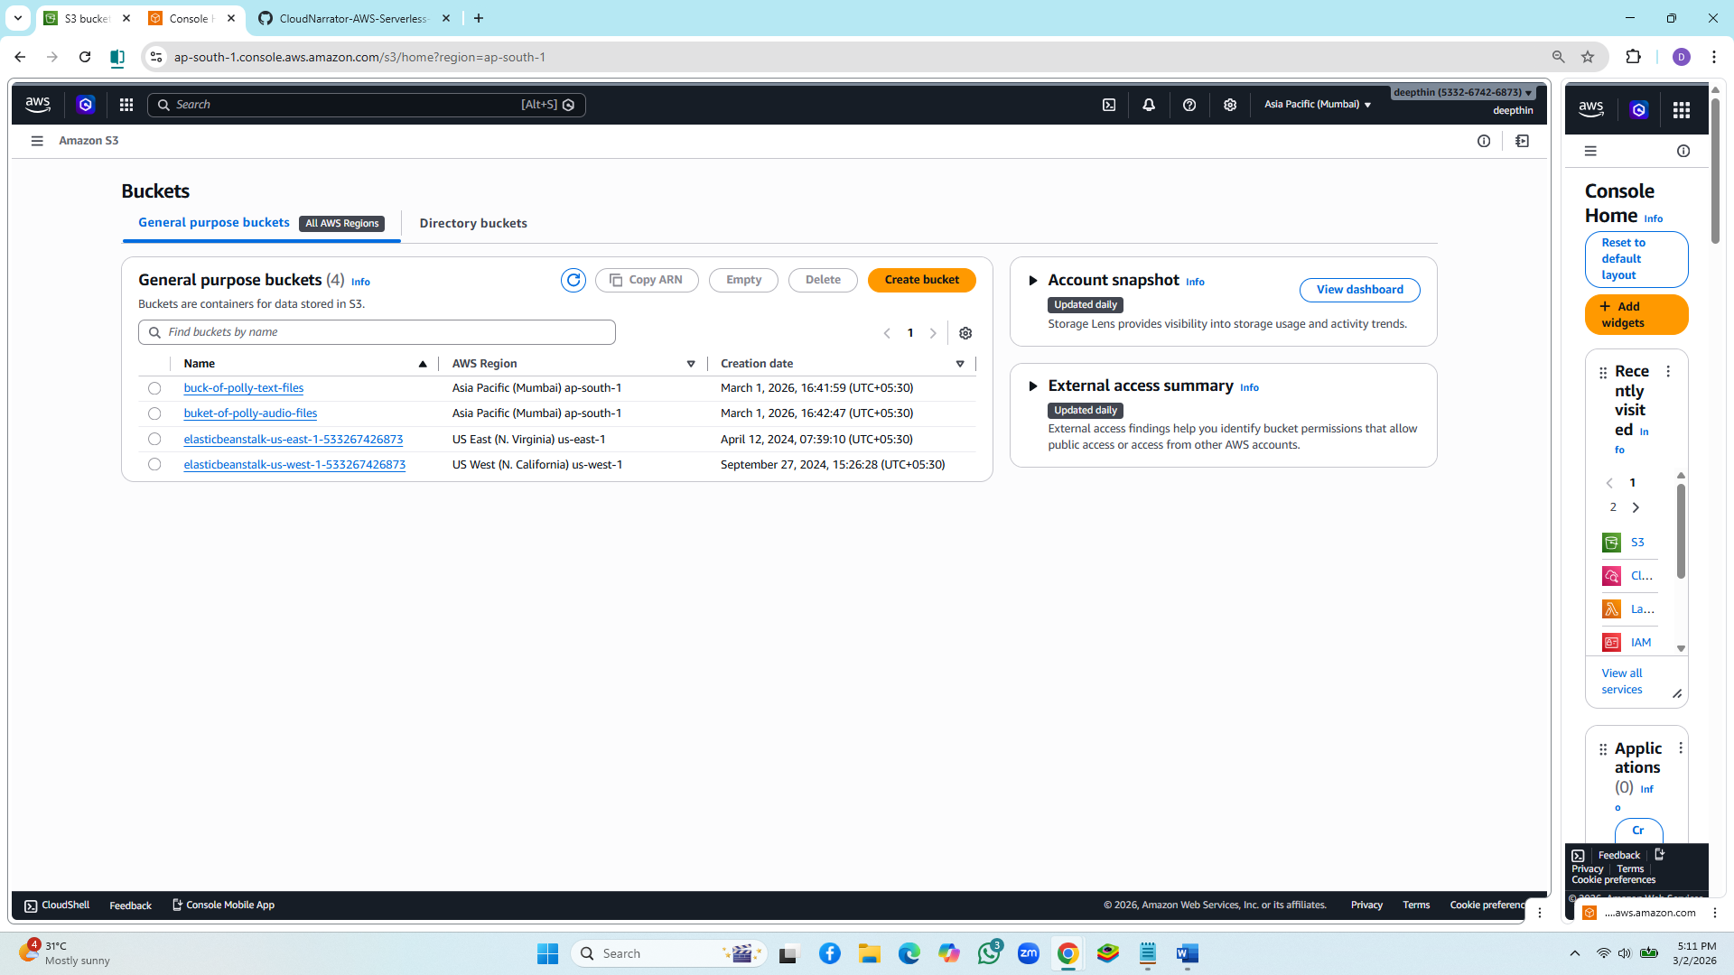
Step 3: Create an IAM role with the name PollyTranslationRole
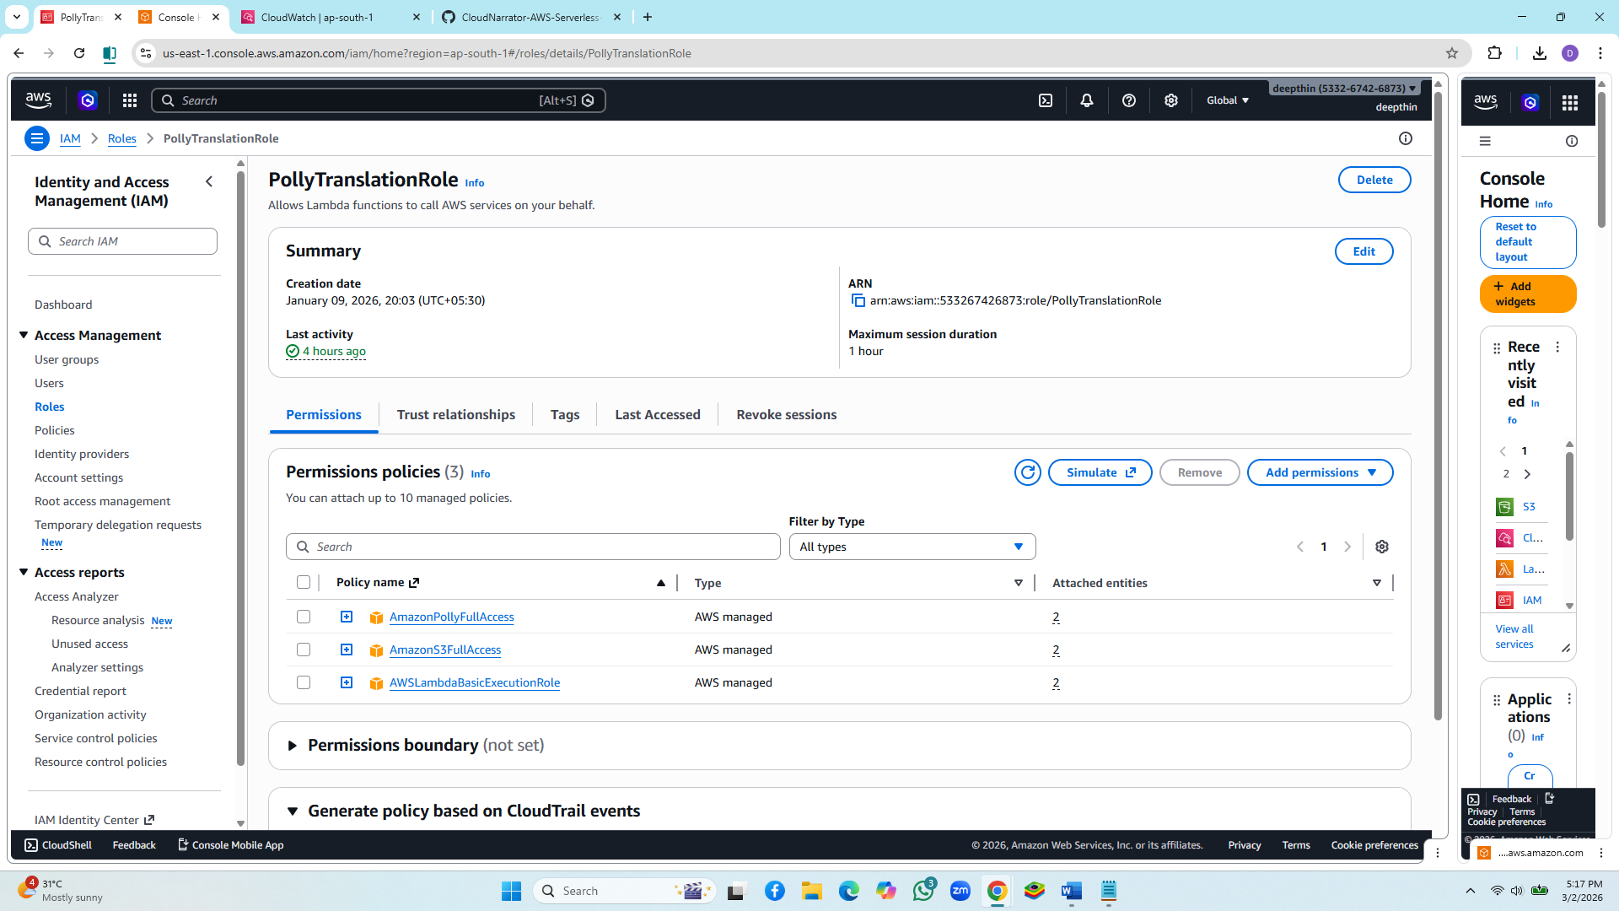
Step 4: Create an IAM Role (IAM Role Name: amc-polly-lambda-role) and attach amc-polly-lambda-policy and AWSLambdaBasicExecutionRole Policies.
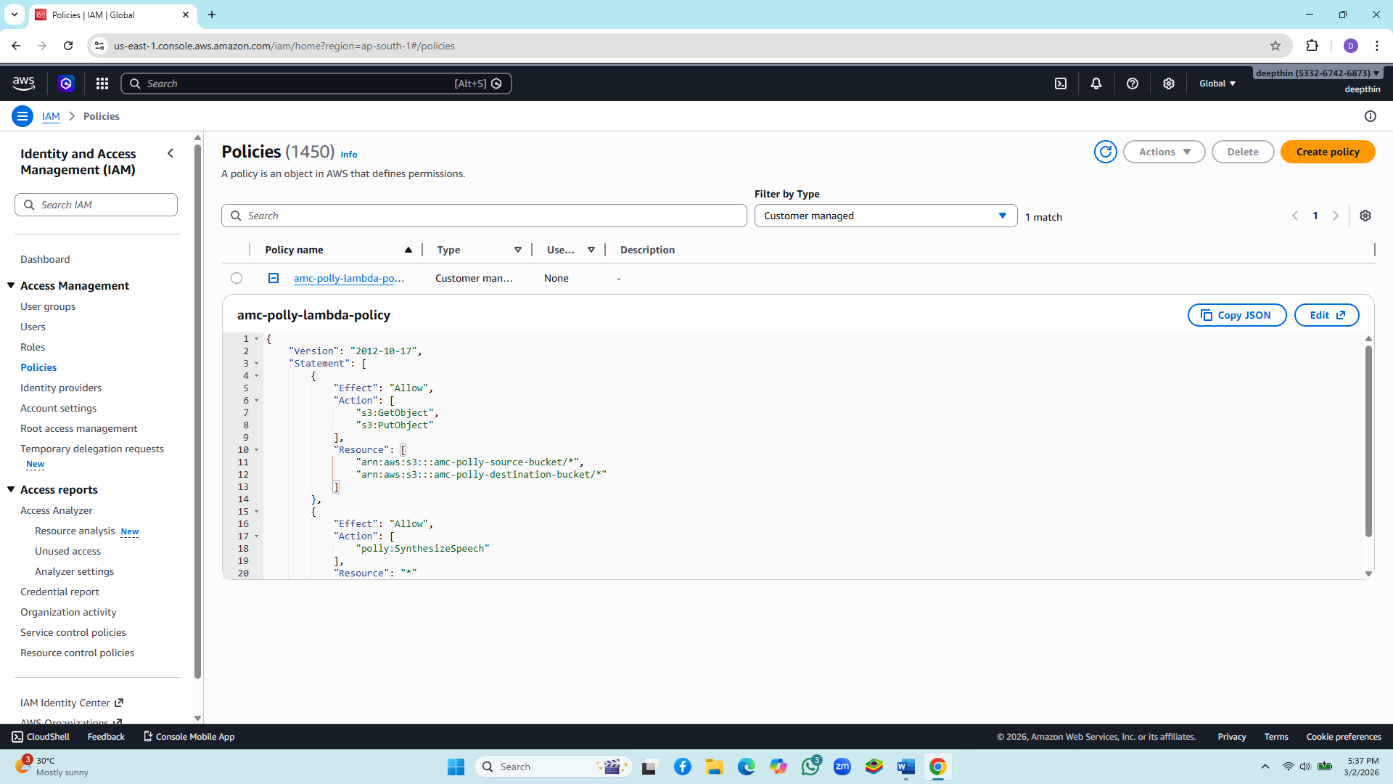
Step 4: Create an IAM Role (IAM Role Name: amc-polly-lambda-role) and attach amc-polly-lambda-policy and AWSLambdaBasicExecutionRole Policies
Step 5: Create and Configure the Lambda Function (Lambda Function Name: TextToSpeechFunction)
import json
import time
import boto3

polly = boto3.client("polly")
s3 = boto3.client("s3")

def lambda_handler(event, context):
try:
record = event["Records"][0]["s3"]
source_bucket = record["bucket"]["name"]
file_key = record["object"]["key"]

# Get text file from S3
obj = s3.get_object(Bucket=source_bucket, Key=file_key)
text = obj["Body"].read().decode("utf-8")
# Convert text to speech
polly_response = polly.synthesize_speech(
Text=text,
OutputFormat="mp3",
VoiceId="Joanna"
)

if "AudioStream" not in polly_response:
raise Exception("Polly did not return audio data")

audio_bytes = polly_response["AudioStream"].read()
audio_key = f"speech-{int(time.time()*1000)}.mp3"

# Upload audio file to another bucket
s3.put_object(
Bucket="buket-of-polly-audio-files", # replace with your bucket
Key=audio_key,
Body=audio_bytes,
ContentType="audio/mpeg"
)

return {
"statusCode": 200,
"body": json.dumps({
"message": "Conversion successful",
"source_file": file_key,
"audio_file": audio_key
})
}

except Exception as e:
print("Error:", str(e))
return {
"statusCode": 500,
"body": json.dumps({"error": str(e)})
}
Set the runtime to Python 3.8. Set the execution role with necessary permissions for S3 and Polly. (Step 4) Add Environment Variables (SOURCE_BUCKET: Name of your source S3 bucket and DESTINATION_BUCKET: Name of your destination S3 bucket.

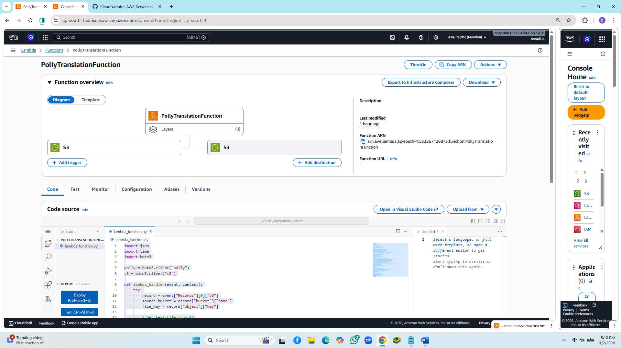

Step 6: Configure S3 Event Notification
Set up an event notification in the source S3 bucket to trigger the Lambda function on new object creation events with the .txt suffix.
